Zenergy 13-day Yoga Cycling Cultural Experience of Hidden Charm North Vietnam
2-14 April 2023

Are you ready for this wonderful once-a-lifetime experience to discover the beautiful breathtaking nature of the North of Vietnam on your yoga mat & bicycle through spectacular mountains, rice fields & waterfalls, colourful cultural shows, traditional villages, richly intriguing cultural places of long history, beautiful white sand beaches and delicious healthy aromatic Vietnamese cuisine?

You start your day with your meditative all-level yoga session to wake up your Zen and energetic body, mind & soul. You enjoy your freshly made delicious breakfast to get ready for the enjoyable bicycle ride of 2-4 hours. You cycle along stunning scenery and outstanding landscape between the towering limestone mountain ranges, overwhelming rice terrace, evergreen tea plantation hills, spectacular waterfalls and water streams. You visit along the way local villages or markets of different ethnic people in their colorful traditional clothes. After your yummy lunch, you relax in the natural hot spring, waterfall or swimming pool of your hotel or homestay in the afternoon. You attend several cultural shows such as water puppet show in Hanoi, Muong dance show in Xuan Son national park. You will visit cultural historical places in Hanoi to learn about the long almost 3000-year-old history of Vietnam. At the end of the trip, you relax at long white sandy beaches at Halong Bay and discovering many caves & islands by kayaking. If you have some muscle pains, your therapy Thai massage & yoga teacher will help you immediately release your pain. After the yin yoga group session to stretch and self massage your whole body, you enjoy healthy delicious Vietnamese diner and sleep soundly before your next day adventure.

If you are not so fit for the day, you can also enjoy a shorter bicycle ride and the accompanying bus will take you sooner to the next hotel to relax. You will be accompanied by a fluent English 15-year experience local bike & tourist guide, a 10-year experienced and passionate English French Dutch & Vietnamese fluent yoga teacher & Thai massage therapist, a bike technician & first aid assistant and 2 bus drivers for your luggage and bikes.

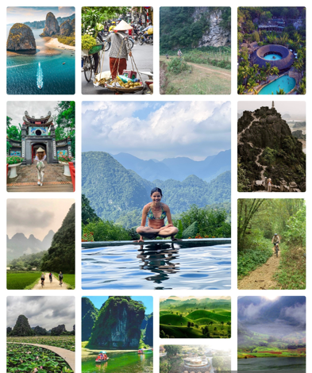
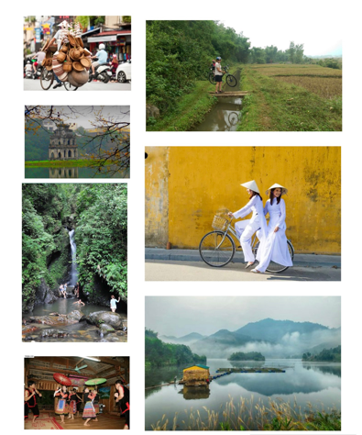
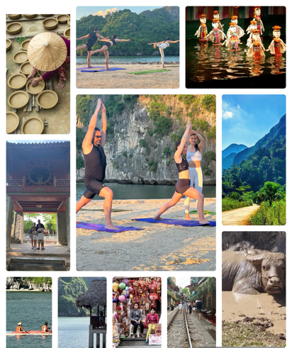

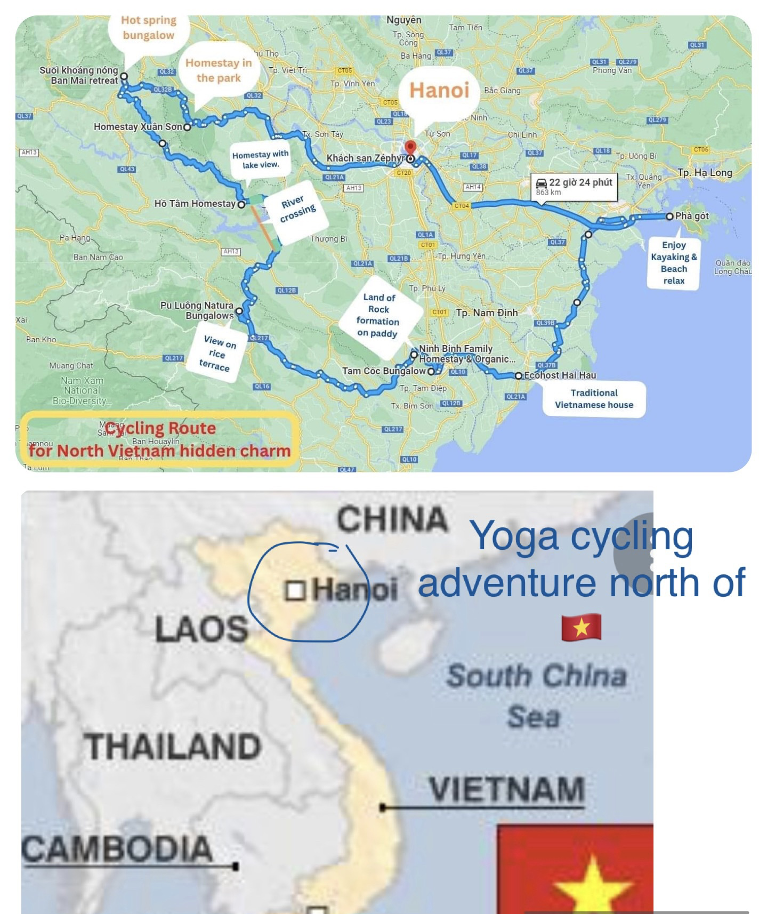

Brief Intinary

Date | Day | Itinerary | Meals | Overnight
02/04/23 | 1 | Ha Noi arrival. | D | Hotel
03 Mon | 2 | Hanoi Cycle around and Pottery Village. | B,L,D | Hotel
04 Tue | 3 | Hanoi – Dong Quang Bridge – Xuân Son Park | B,LD | Homestay
05 Wed | 4 | Xuan Son – Suoi Chieu – Ban Mai Hotspring | B,L,D | Bungalow
06 Thu | 5 | Ban Mai Hot spring – Tam Lake | B,L,D | Homestay
07 Fri | 6 | Ho Tam – Pu Luong | B,L.D | Stilt house
08 Sat | 7 | Pu Luong – Van Long Nature reserve | B,L,D | Bungalow
09 Sun | 8 | Van Long – Trang An – Hoa Lu – Tam Coc | B,L,D | Bungalow
10 Mon | 9 | Tam Coc – Giao Thuy | B,LD, | Eco home
11 Tue | 10 | Giao Thuy – Cat Ba island. | B,L,D | Hotel
12 Wed | 11 | Cat Ba island visit the bay | B,L,D | Hotel
13 Thu | 12 | Cat Ba island – Hanoi. | B.LD | Hotel
14 Fri | 13 | Check out of hotel in Hanoi for your own trip extension or departure. | B

Day-by-day Itinerary:

Day 1: Hanoi Arrival

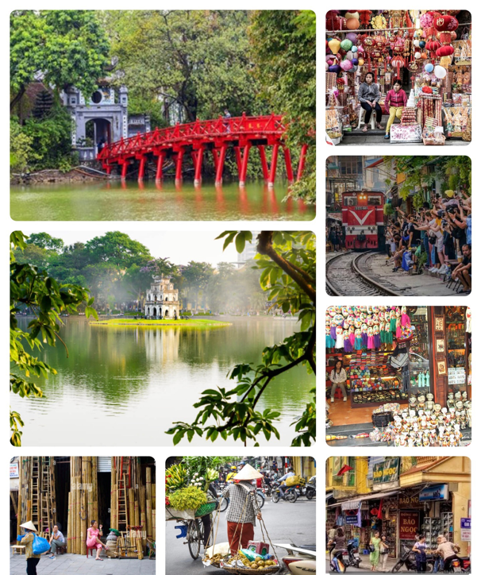
- Upon your arrival in the Hanoi Noi Bai Airport, our driver with the Zenergy Studio welcome sign awaits you in the arrival hall and take you to hotel in Hanoi where you can rest. At 15h, you will enjoy a 2-hour walking tour to tourist attractions in the old quarter of Hanoi : 36-old tradtional streets & Hoan Kiem Lake: The first chapter of Hanoi’s Old Quarter history started in the 11th century when the King Ly Thai To decided to move the capital from Hoa Lu (Ninh Binh) to Thang Long (Hanoi). As the result, many skilled craftsmen gathered around this royal palace to sell their products, creating a cluster of villages each specialized in a different type of craft. These specialized villages, or guild, made it easier for craftsmen with the same skills to work together and for the products to be transported to a specific street. Overtime, this collection of villages became a busy trading center, especially reached its peak under the French colony, when it became a well-known marketplace to trade both the local goods and those from China, France and India.

- You will meet and greet your tour friends at the trip briefing in the hotel lobby at 17h. After a 30-min chair yoga to relax sore body at 18h at Hoan Kiem Lake, you will enjoy your first yummy welcome dinner with local food. Overnight in Hanoi

Day 2: Hanoi Cultural walk & Cycling in Hanoi countryside visiting Pottery Village (walk 10km & cycle around 20-30 km)

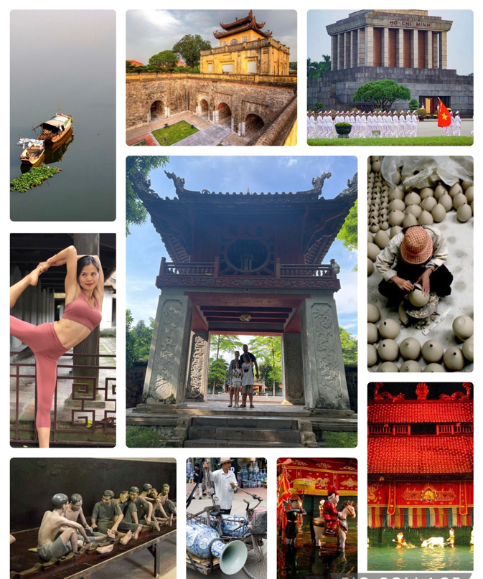

- 7h: Morning Yoga at the Hoan Kiem Lake near your hotel
- 8h: Breakfast
- 9h: You will visit top tourist attractions of Hanoi on foot & by our bus: Van Mieu Old Temple of Literature of 11th Century, Ho Chi Minh Mausoleum, Thang Long Imperial Citadel & Hoa Lo Prison.
- 13h: Simple lunch before our guides and van taking you to our bike store for a ride to visit the outskirt of Hanoi to enjoy the local culture & countryside view along the Red river with guava, green herbs garden & ceramics village. We cyle back to bike store in the late afternoon.
- 17h30 short walk from your hotel to enjoy the Water puppet show - a traditional puppet dance of Vietnam.

Van Mieu, The old Temple of Literature, is a temple dedicated to Confucius in Hanoi, northern Vietnam. The temple also hosts the Imperial Academy_Vietnam's first national university. The temple was built in 1070 at the time of Emperor Ly Thánh Tông. It is one of several temples in Vietnam which is dedicated to Confucius, sages and scholars. The temple is located to the south of the Imperial Citadel of Thang Long. The various pavilions, halls, statues and stelae of doctors are places where offering ceremonies, study sessions and the strict exams of the Viet took place.

The President Ho Chi Minh Mausoleum is a mausoleum which serves as the resting place of Vietnamese Revolutionary leader and President Ho Chi Minh in Hanoi, Vietnam. Among the 20th century revolutionaries, Ho Chi Minh led battle against colonial power in Vietnam. The forces he led fought and defeated the Japanese, the French and finally the Americans in his fight for Vietnamese independence. It is a large building located in the center of Ba Dinh Square, where Ho, Chairman of the Workers' Party of Vietnam from 1951 until his death in 1969, read the Declaration of Independence on 2 September 1945, establishing the Democratic Republic of Vietnam.

The Imperial Citadel of Thang Long is a complex of historic imperial buildings located in the centre of Hanoi, Vietnam. It was first constructed in 1011 under the reign of Emperor Ly Thái To of Ly dynasty. The royal enclosure was first built during the Ly dynasty (1010) and subsequently expanded by the Tran, Lê and finally the Nguyen dynasty. It remained the seat of the Vietnamese court until 1810, when the Nguyen dynasty chose to move the capital to Hue. The royal palaces and most of the structures in Thang Long were in varying states of disrepair by the late 19th century with the upheaval of the French conquest of Hanoi. In mid-1945 the Citadel was used by the Imperial Japanese Army to imprison over 4000 French colonial soldiers captured during the Japanese coup d'état in French Indochina in March 1945.

Hoa Lò Prison was a prison in Hanoi originally used by the French colonists in Indochina for political prisoners, and later by North Vietnam for U.S. prisoners of war during the Vietnam War. During this later period, it was known to American POWs as the "Hanoi Hilton". The prison was demolished during the 1990s, although the gatehouse remains as a museum. The prison was built in Hanoi by the French, in dates ranging from 1886 to 1901 when Vietnam was still part of French Indochina. It was intended to hold Vietnamese prisoners, particularly political prisoners agitating for independence who were often subject to torture and execution.By 1954 it held more than 2000 people with its inmates held in subhuman conditions, it had become a symbol of colonialist exploitation and of the bitterness of the Vietnamese towards the French.

Water puppetry dance was born about 10 centuries ago in the Red River Delta. This type is often performed on festivals, village festivals, happy days, New Year's Day, using puppets to play tricks, perform plays on the water. Water puppetry is also considered a unique intangible cultural feature of the Vietnamese nation. Due to its uniqueness, from the art of folk elements, water puppetry has quickly become a traditional art that can be compared with tuong and cheo, which are arts with a high position in the stage background. Puppetry is available in many countries around the world, but water puppetry is only available in Vietnam

Bat Trang Pottery Village is located on the left bank of the Red River, now in Bat Trang Commune, Gia Lam District, Hanoi, more than 10km southeast of the city center. This is a traditional village famous for ceramic products.This craft village was formed during the Ly Dynasty. Experiencing more than 500 years of history with many ups and downs at the same time, the name Bat Trang still exists and is growing until now. Bat Trang ceramic products have always been appreciated for their quality, have many designs, models and types, divided into groups according to their functions, such as household ceramics, worship items, and fine ceramics. art, construction ceramics and decorative ceramics

Day 3: Hanoi – Da Chong – Long Coc tea plantation – Xuan Son Natioanl Park ( Cycle 40 – 50km / Total moving distance 135km)
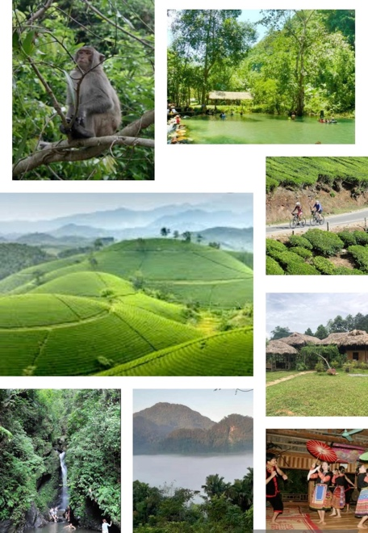
- 7-8h: Morning Yoga at Hoan Kiem Lake near your hotel
- 8-9h: Breakfast
- 9h: We leave Hanoi busy city by van to Da Chong where we will start cycling to cross black river. The ride will take you to beautiful Tea Plantation Long Coc, and you can have chance to visit waterfall on the way to Xuan Son park. Enjoy the ride through villages to Park area.
- 15h: Check in Homestay and rest or walk to a stream & relax
- 17h: Yin Yoga
- 18h30: Diner
- 20h: After dinner at homestay, we will have chance to enjoy the local dance performance of the Muong ethnic people to understand more about the local culture.

The Long Coc Tea Hill is one of the most beautiful tea hills in Vietnam. The tea “oases” makes Lang Coc known as “Ha Long Bay” in the midlands. The total area of tea hills is up to 10,000m2. You can walk between the winding road with two sides of long green tea hills that follow each other to the horizon.

The Muong are an ethnic group native to northern Vietnam. The Muong is the country's third largest of 53 minority groups, with an estimated population of 1.45 million (according to the 2019 census). The Muong people inhabit the mountainous region of northern Vietnam. They are most closely related to the ethnic Vietnamese (Kinh). Considered the only surviving descendants of the early Vietnamese, the Muong, unlike the lowland northern Vietnamese, have been little influenced by the Chinese. They staged unsuccessful rebellions against the French-ruled Vietnamese in 1822, 1833, and in the 1880s. Their language, is a subset of the Vietic branch of Mon-Khmer, a language family of Austroasiatic stock. The Muong social structure is patrilineal and has as its foundation the extended family; only males own property. Originally, the Muong had an organized feudal system of landed nobility and a peasant class. The Muong economic base is agrarian; wet rice is grown on terraced land, and dry rice is also cultivated. They raise pigs, oxen, buffalo, and chickens; hunting is done in order to provide meat for festivals. They live in clusters of 10–25 houses, portions of which are used to hold animals and store crops.

Xuan Son National Park is located in Tan Son district, Phu Tho province; has a forest ecosystem on limestone mountains, a typical ecosystem of the North of Vietnam with tropical and subtropical forests, there are still many rare and precious species of flora and fauna typical for the Northern mountainous region. value of scientific research, conservation of genetic resources and environmental education. Xuan Son National Park is also considered a "green lung" and is an attractive tourist destination located in the southwest of Phu Tho province, which has a great effect in climate regulation & carbon absorption. This is also a place to protect the head-water of Bua river, which provides water for production and daily life of people living around the area.

Day 4: Xuan Son National park – Suoi Chieu lake – Ban Mai hotspring - (cycle around 40- 50km / total moving distance 50 km)
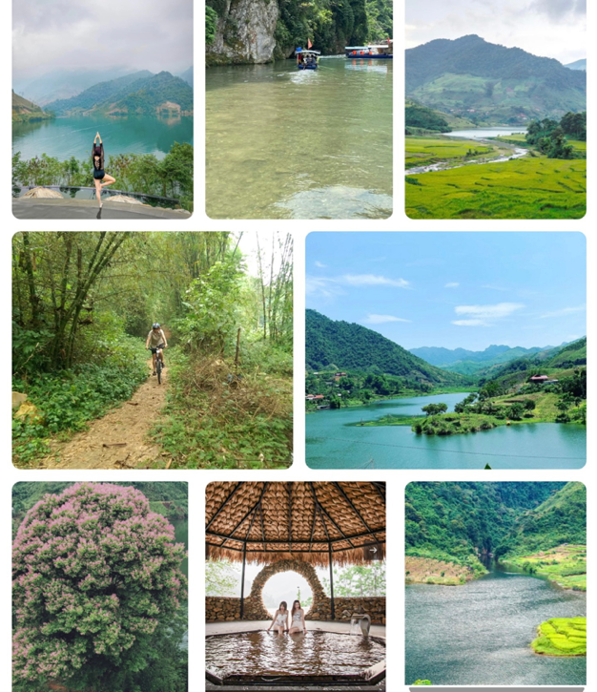
- 7-8h: Morning Yoga at Homestay in Xuan Son park
- 8h: Breakfast
- 9h: We start cycling from Homestay, enjoying the back road of Xuan Son park before to the National Rd 32. We enjoy some stops and lunch on the way.
- 14h: Check in to rest, relax Ban Mai Hot Spring retreat by the lake
- 17h: Yin Yoga
- 18h30: Diner
Suoi Chieu Lake is an irrigation project with a scale of more than 50 hectares, with a capacity of over 4 million m3 of water, from two main streams, Chieu and Lat streams. As one of the large artificial lakes, Suoi Chieu is like a charming painting on the land of Phu Hoa, becoming an ideal destination for tourists who love wild and rustic scenery. The lake surface is clear, rippled, on both sides are villages surrounded by lush forests.

Ban Mai Retreat is a beautifyl hidden natural mineral hot spring of 45°C in the valley of the Suoi Chieu Lake with amazing beautiful view and zen atmosthere to relax and unwind & recharge.

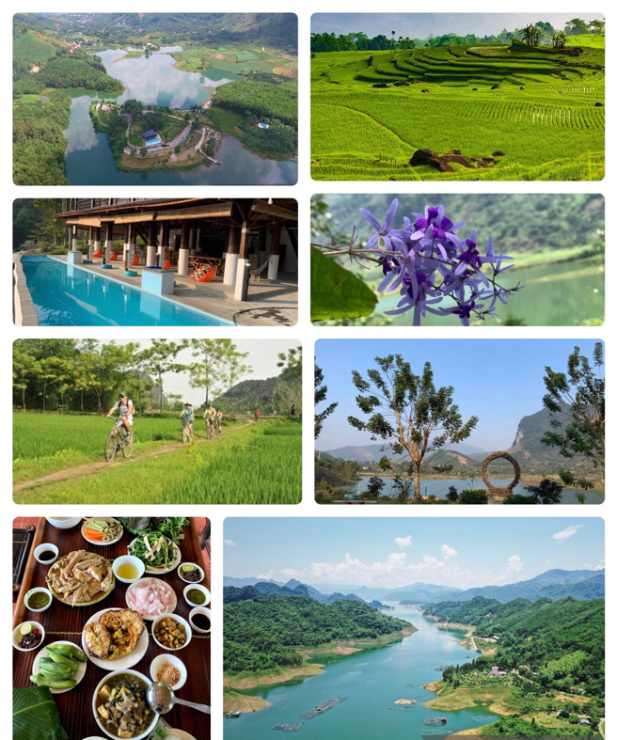
Day 5: Ban Mai retreat – _Da Bac dist – Tam lake - (Cycling of around 50km / total moving distance 122 km)
- 7h: Morning Yoga
- 8h: Breakfast
- 9h: We head to Hoa Binh Reservoir of Da (Black) river, the moutainous, hilly roads enjoy the countryside view. In the afternoon, we head to Cao Son commune of Da Bac Dist.
- 15h: We check in a homstay in Tam Lake to relax.
- 17h: Yin Yoga
- 18h30: Diner
Tam Lake is located in Cao Son Commune, Da Bac District, located about more than 90km from Hanoi. It is surrounded by rocky mountains. Nature favors this place, so the climate here is cool and fresh. The clear lake water combined with blue clouds creates a majestic natural picture. It is located at an altitude of nearly 1000m above sea level, many rocky mountains, alternating lakes create a relaxing space.

Day 6: Tam lake - _a Bia village – Black river boat crossing – Ba Khan – Pu Luong. ( Cycling of around 40 – 50km – Total moving distance of 100 km)
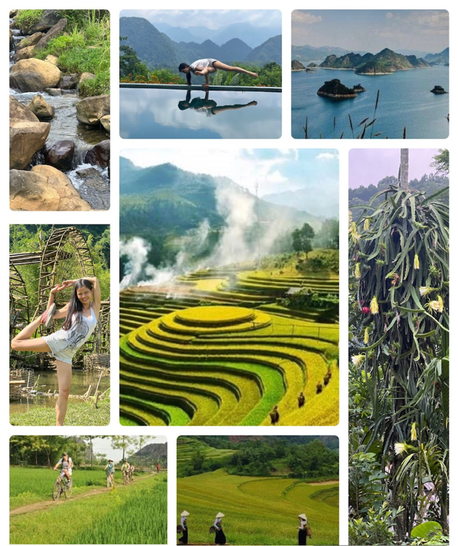
- 7h: Morning Yoga
- 8h: Breakfast
- 9h: We start cycling to Da Bia Village where we take our bikes on a boat to cross to the other side where we start a ride along the old scenic road by black river. Enjoy beautiful view on Black River (Hoa Binh) Reservoir. Simple picnic lunch on the way. We continue our ride to Pu Luong where we will have chance to interact with local people to understand more about their life as well as enjoy the tranquil and beautiful sightseeing en-route.
- 15h: We take a bus trip to Pu Luong to check in the Natura stilt house and enjoy the view on rice paddy by the pool.
- 17h: Yin Yoga
- 18h30: Diner

Hoa Binh reservoir or Hoa Binh hydroelectricity reservoir is a water storage facility to supply Hoa Binh hydropower plant. Store water in the dry season. This is the largest artificial reservoir in Vietnam, located on the Da River, with a length of 230 km from Hoa Binh to Son La. The volume of the lake is about 9.45 billion cubic meters. The lake has a total of 12 bottom discharge outlets. If all 12 bottom discharge gates are opened, the entire city of Hoa Binh and downstream areas will have to be relocated.

One glance at the Pu Luong Nature Reserve and you’ll see why the ethnic Thai people made this enchanting valley their home long ago. Endless mountains, fertile valleys and pristine jungle are just a few good reasons to visit. Pu Luong is dotted with quaint hamlets and villages throughout the park, each with its own unique history. Most of the communities in the reserve are Thai people, an ethnic group with two local branches, White Thai and Black Thai. The Thai people are highly skilled at wet rice cultivation and their homes are built in a raised stilt style. Pu Luong’s mountains are covered with tropical rainforest, while the valley is a series of cultivated rice terraces. Take a walk along the valley floor or in the foothills to get up close with the area’s flora and fauna. Listen to the waterwheels and forest sounds, wave at farmers and grazing water buffalo, and snap pictures of the greenery and wildlife. Simply being in Pu Luong Nature Reserve is a breath of fresh air.

Day 7: Pu Luong – Van Long – Bai Dinh ( Ninh Binh) (Cycling of around 50 – 60km / Total moving distance of 123km)
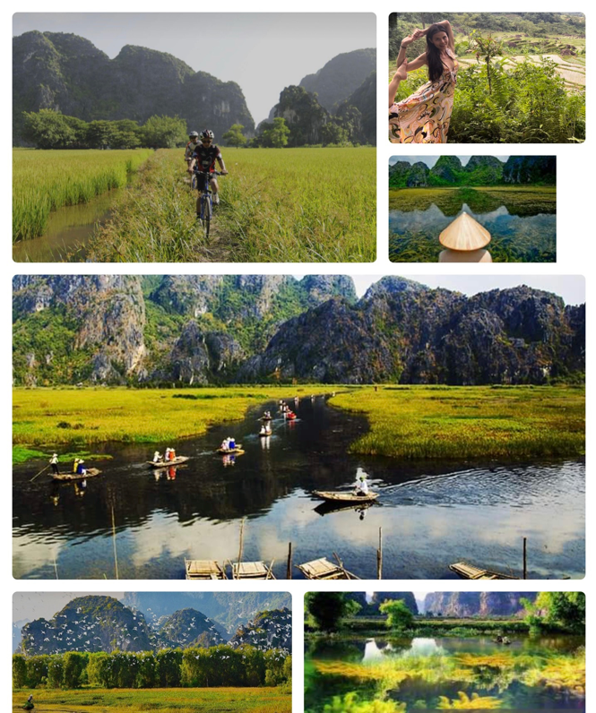
- 7h: Morning Yoga
- 8h: Breakfast
- 9h: Leave Nature reserve and cycling to Ho Chi Minh road the to Ninh Binh Province. Enjoy the countryside and friendly people along the way to Cuc Phuong National Park. Lunch on the way before arriving in Van Long Nature reserve.
- 17h: Yin Yoga
- 18h30: Diner

Van Long Wetland Nature Reserve is a nature reserve in Gia Viễn District, along the Northeastern border of Ninh Binh Province, Vietnam. The site is one of the few intact lowland inland wetlands remaining in the Hong River Delta. Limestone karst is surrounded by the freshwater lake, marshes and swamps. Together with subterranean hydrological systems they form a wetland complex, which is very rare in the Mainland Southeast Asia. Van Long Wetland Nature Reserve is a habitat for the critically endangered Delacour's langur and is the only place where the species can be observed in the wild.

Day 8: Van Long – Cycle to Trang An caves – Tam Coc ( Ninh Binh) ( Cycling distance of 30km)
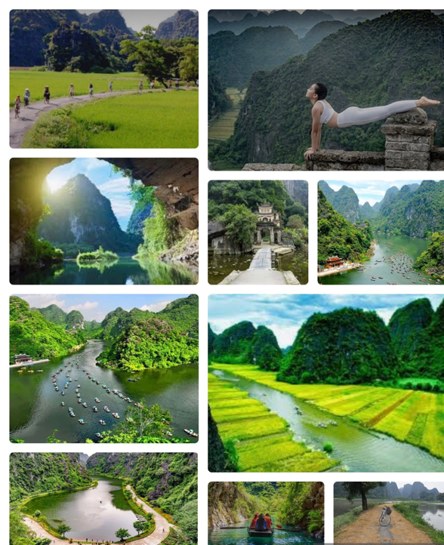
- 7h: Morning Yoga
- 8h: Breakfast
- 9h: We cycle and enjoy the nature & countryside road and get inside local life. We stop for lunch in a local restaurant, then move to Trang An boat pier for an excursion on the sampan to explore the system of limestone caves and hidden lagoons. In the afternoon, after the boat rowing, we cycle to Tam Coc and check in our hotel to relax and enjoy the nature around.
- 17h: Yin Yoga
- 18h30: Diner

Trang An eco-tourism area is an eco-tourism area located in the Trang An World Heritage Complex in Ninh Binh province. This place has been classified as a particularly important national monument by the Vietnamese government and recognized by UNESCO as a dual world heritage site since 2014. Trang An with a system of limestone mountains with a geological age of about 250 million, over a long period of time weathered by the change of the Earth, the climate, the sea advance, the sea recedes has brought in hundreds of valleys, caves, lakes and lagoons. This scenic spot is a place to preserve and contain many ecosystems of wetlands, forests on limestone mountains, archaeological sites and historical and cultural relics. The system of rocky mountains, rivers, streams, forests and caves in Trang An was very dangerous, so it was chosen by King Dinh Tien Hoang as the southern citadel to protect the capital Hoa Lu in the 10th century, and then the Tran Dynasty used it as Vu Lam palace during the Mongol resistance. At present, there are many historical relics of Dinh and Tran dynasties.

Tam Cốc, literally "three caves", consists of three natural caves — Hang Cả, Hang Hai, and Hang Ba — on the Ngô Đồng River. Tourists are taken in small boats along the river from the village of Ván Lám, through rice fields and limestone karsts, through the caves, and back. Local women serve as guides and attempt to sell embroidered goods to their passengers. The guides are well known for rowing their boats using their feet. The area is nicknamed "the inland Ha Long Bay

Day 9: Tam Coc (Ninh Binh) – Giao Thuy (cyling distance of 50km)

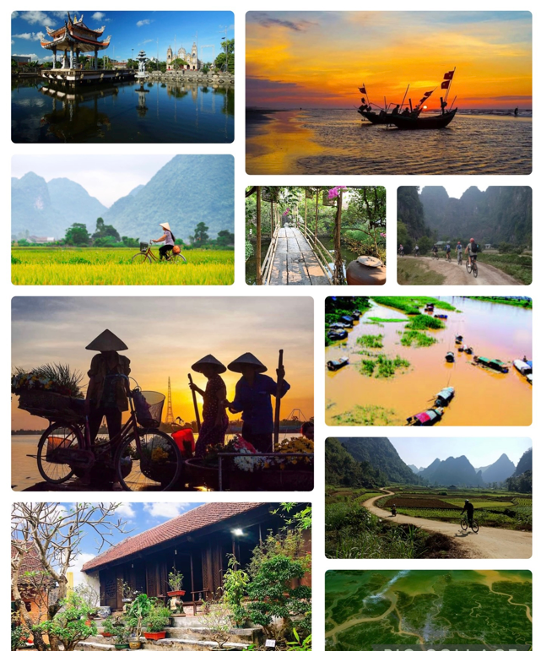
- 7h: Morning Yoga
- 8h: Breakfast
- 9h: Farewell to Ninh Binh, we go to the sea, enjoy the spectacular view, countryside life of Red River delta. An easy ride on flat village roads
- 14h: Check in Eco Host homestay and explore locals
- 17h: Yin Yoga
- 18h30: Diner

The Red River Delta or Hong River Delta is the flat low-lying plain formed by the Red River and its distributaries merging with the Thái Bình River in northern Vietnam. Hong is a Sino-Vietnamese word for "red" or "crimson." The delta has the smallest area but highest population and population density of all regions. The region, measuring some 15,000 square kilometers (6,000 sq. mi) is well protected by a network of dikes. It is an agriculturally rich and densely populated area. Most of the land is devoted to rice cultivation.

Ecohost, also known as ecotourism, specializes in quality experience tourism activities in Vietnamese villages. In this tour, we would like to introduce you to an experience in the countryside of the Red River Delta of Vietnam through traditional houses, daily life of local people. You can also visit traditional craft villages while staying in this countryside.

Day 10: Giao Thuy – Cat Ba

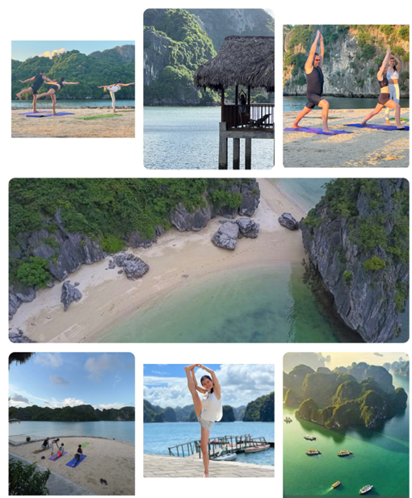
- 7h: Morning Yoga
- 8h: Breakfast
- 9h: We take the Bus transfer to Hai Phong and Got Ferry to Cat Ba island. After a short transfer to Cat Ba town, we check in hotel and take a rest or free to explore the beach and sunset
- 17h: Yin Yoga
- 18h30: Diner

Day 11 : Kayaking and Beach relax in Cat Ba
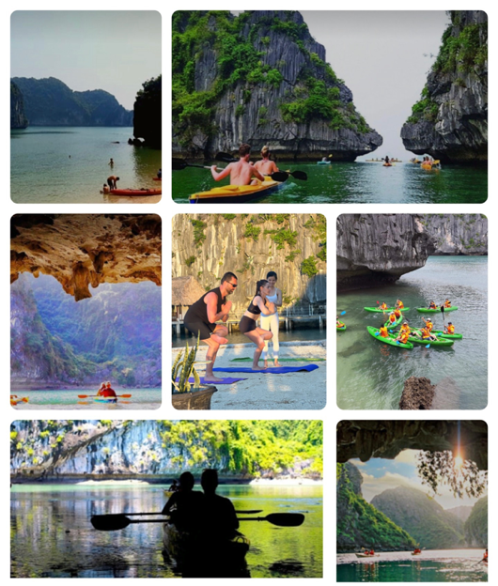
- 7h: Morning Yoga
- 8h: Breakfast
9h: We get on our private cruise and start the kayaking trip. Our crew will take us to beautiful spots for kayaking to explore the caves, white sand beaches, swimming in clear and nice water of the bay.
- Afternoon, we will get back to the bungalow for the second night stay. Enjoy the beach sunset
- 17h: Yin Yoga
- 18h30: Diner

Nature has endowed Cat Ba with unique & beautiful wild landscapes. Cat Ba's air is fresh and cool, majestic natural scenery with limestone mountains interspersed with mysterious caves such as Thien Long, Hoa Cuong, Trung Trang, and Quan Y. Cat Ba archipelago has hundreds of beaches with fine sand, clear blue and peaceful water such as: Van Boi, Cat Dua, Cat Vang ... and beautiful bays such as: Lan Ha, Ben Beo, Cat Ba, Tung Thu...This archipelago is more than 7000 hectares wide, possessing over 400 different large and small islands, with beaches that have not been exploited much. is the wild beauty, quiet space nowhere else, very suitable as a destination for those who want to find a new space to relax.

Day 12: Cat Ba Island – Hanoi
- 7h: Morning Yoga
- 8h: Breakfast
9h: Free at your leisure until check out at noon then get on the transfer to leave Cat Ba town to ferry.
We will travel to Hai Phong then journey to Hanoi.
- 17h: Yin Yoga at Hoan Kiem Lake
- 18h30: Farewell Diner

Day 13: Free - Departure Day from Hanoi
- 7h: Morning Yoga
- 8h: Breakfast
- 11h: Check out
- Free time shopping
- you are free to continue your journey further south or take flight back home.

We can advise you on your extension trip to the the middle and south of Vietnam

Note:
This itinerary is subject to change in accordance with any change in government and community regulations and circumstances beyond our control such as natural calamities (typhoon, floods); flight/train/boat delays, rescheduling or cancellations; traffic jams, vehicle breakdown; accidents; medical evacuations; riots; strikes; etc. The ride can be customized in length, as the support vehicle can be used at any time by tired riders.

Tour price:
$2499 per person for 13-day all-inclusive of cycling yoga cultural expereince in a shared accommodation in twin/double room

- 50% prepayment on reservation
- 50% a month before departure

($2899 per person if preferred single room occupation)

Number of participants: Min 8 – Max 14 people. Min age 14+

Tour price includes:
- 12 nights in comfortable shared accommodation in a twin/double room of variation type: 3-4 star hotel in cities, local hot spring resort, bamboo bungalow, shared still house with simple facilities in jungle & traditional local houses.
- All transfers and transportation with air-con vehicles (depends on the group size): comfortable van of mini bus from from Day 2 to Day 13 on the days of cycling:
- mini van to carry clients and 1 luggage truck to carry bikes
- you can rest on the support vehicle if you can’t cycle
- All delicious healthy locally freshly made meals (12 Breakfasts, 11 Lunches 12 Diners)
- All entrance fees as mentioned in the itinerary
- 10-year experienced yoga teacher & Thai massage therapist fluent in English, Dutch, French & Vietnamese to teach almost twice daily yoga classes and release your specific pain with Thai massage on the day
- 15- year experienced professional English speaking cycling guide throughout & medical kits
- 1 mechanic to escort the group on days of cycling (this could be the driver)
- Quality bikes(Giant, Trek) of 15-21 inches & spare bikes (1-2 bikes depending on group size)
- Yoga mat & bike helmet but feel free to bring your own
- Snacks & fruits on cycling days
- Mineral water on van/bus on days with transfer & sightseeing. You can refill your bike water bottle from our free 19L water big bottle
- Boat trip in Trang An or Tam Coc and kayaking trip in the bay
- Water puppet show tickets & Muong dance local show
Meet your passionate Vietnamese Belgian yoga teacher & thai massage therapist:

I can’t wait to meet you and share with your this unique experience of doing mediative yoga & cycling in my beautiful original country that I design together with my trustworthy cycling tourist agency in Vietnam. I am currently the owner and yoga teacher and thai massage therapist of my own Zenergy Studio that exist for almost 9 years in Meise in Belgium. I have a deep passion for human antomy that enables me helping many customers ending their chronic pain with therapy yoga & thai massage.

Quality Bikes

Mix of comfortable & relaxing accommodation: Hotels & Homestay & Resort:

Tour Price excludes:
- International airfares and airport taxes in & out Vietnam
- Travel insurance (compulsory)
- Airport transfer to hotel: can be arranged by us and you can pay additionally to your price
- Visa to Vietnam (if any)
- Beverages (Mineral water, tea, soft drinks, alcohol) and other meals do not indicate in the itinerary
- Optional excursions
- Excess luggage charges
- Tips for tour guides and drivers
- Items of a personal nature such as telephone, laundry bills, shopping, etc.…
- All others not indicated in the itinerary
- Any additional expenses caused by reasons beyond our control such as natural calamities (typhoon, floods); flight/train/boat delays, rescheduling or cancellations; traffic jams, vehicle breakdown; accidents; medical evacuations; riots; strikes; etc.

April weather in Northern Vietnam:
- Spring weather 22-30° - suitable temperature for movement activities: Cycling & Yoga & Hiking
- Mountains often have morning fog. Sometimes spring drizzle still occurs, Evening climate is still chilly, light jacket is required.

What to bring for the bike program:
- Cycling shoes, cycling gloves, cycling clothes & light jacket
- Pedal, seat cover according to your own preferences. (if you don’t want to you our gears)
- Bicycle water bottle (according to preference)

